AUTOMATIC CASE ERECTOR

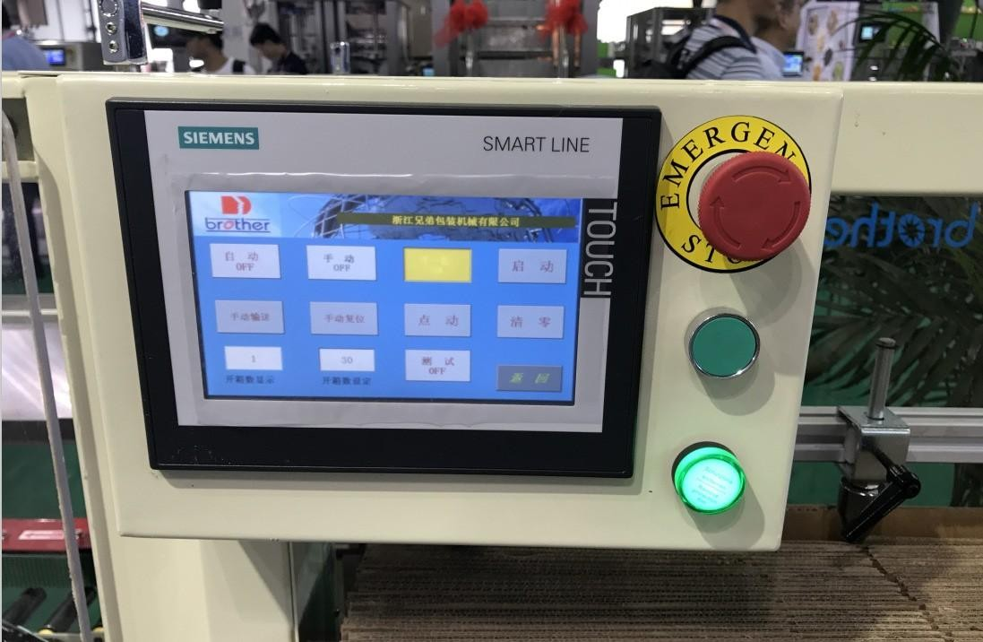

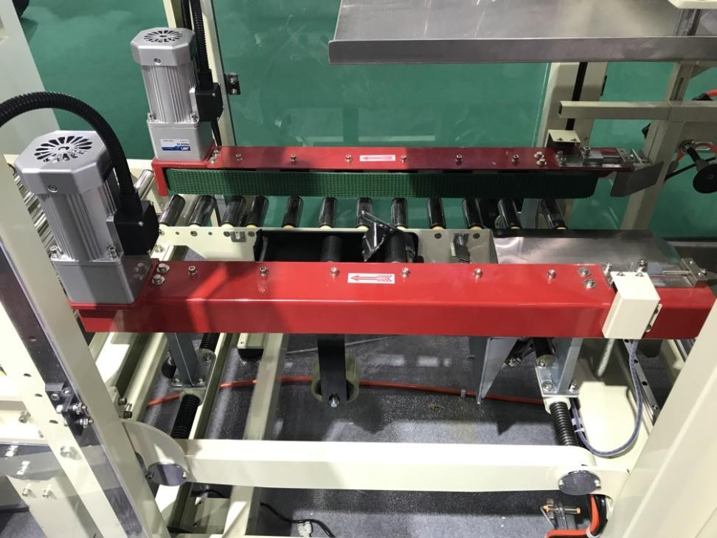

TECHNICAL SPECIFICATION:

Model | NTPL-4035
Suitable Case | L200-600mm/W120-400mm/H120-350mm
Height of table | Min.H550mm Max.H700mm
Output Speed | 10-12 carton/min.
Power | Single phase, 220V/ 50/60HZ , 300W
Air Source | ＞500L/min、 0.4~0.8 Mpa
Opp tape | W50mm or W60mm or W75mm

MAKE OF COMPONENTS:

No. | Name | Brand Name
1 | Touch screen | Simens/German
2 | PLC | Simens/German
3 | Cylinder | Airtac/Taiwan
4 | Mid-relay | OMRON/Japan
5 | Switch | Schneider/German

